Ideation Phase
Brainstorm & Idea Prioritization Template
Date | 24 October 2026
Team ID | [Individual Project Submission]
Project Name | IMovies — Movie Ticket Booking Made Simple
Maximum Marks | 4 Marks

Brainstorm & Idea Prioritization Template: Brainstorming provides a free and open environment that encourages everyone within a team to participate in the creative thinking process that leads to problem solving. Prioritizing volume over value, out-of-the-box ideas are welcome and built upon, and all participants are encouraged to collaborate, helping each other develop a rich amount of creative solutions.
Use this template in your own brainstorming sessions so your team can unleash their imagination and start shaping concepts even if you're not sitting in the same room.
Reference: https://www.mural.co/templates/brainstorm-and-idea-prioritization
Step-1: Team Gathering, Collaboration and Select the Problem Statement
The brainstorming initiative was structured into a dedicated collaborative session with focused preparation, goal setting, and facilitation guidelines:
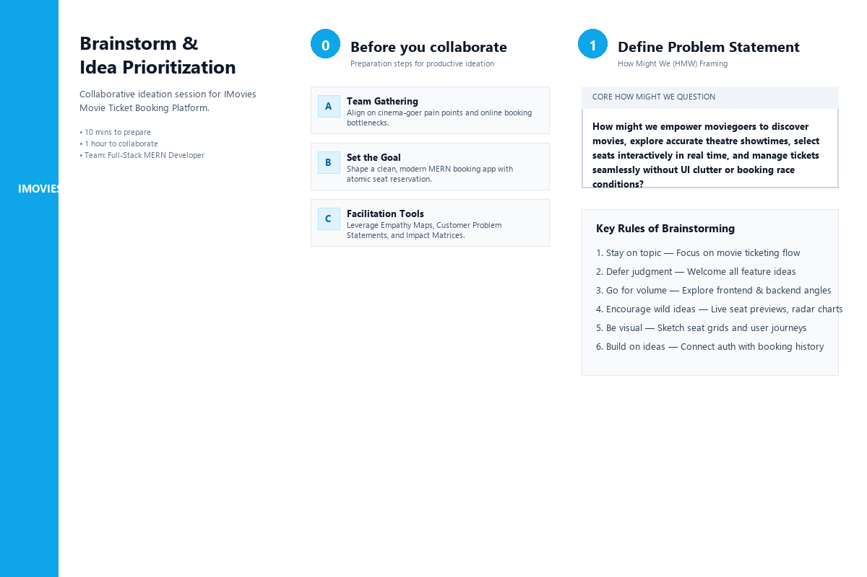
Figure 3.1: Mural Step 1 — Before You Collaborate & Define Problem Statement
- A. Team Gathering: Define participant roles, review user empathy discoveries, and align on project objectives before commencing ideation.
- B. Set the Goal: Design a lightweight, lightning-fast, and concurrency-safe MERN stack movie ticket booking platform called IMovies.
- C. Facilitation Tools: Apply Mural facilitation principles, customer journey mapping, and the Impact vs. Feasibility matrix.
Core 'How Might We' (HMW) Question
"How might we empower moviegoers to discover movies, explore accurate theatre showtimes, select seats interactively in real time, and manage tickets seamlessly without UI clutter or booking race conditions?"
Key Rules of Brainstorming Adopted
- 1. Stay on Topic: Maintain strict focus on movie discovery, showtimes, seating grids, and booking lifecycle.
- 2. Defer Judgment: Every feature suggestion is valid during initial idea generation; criticism is deferred until the prioritization stage.
- 3. Go for Volume: Maximize the volume of ideas across frontend, backend, database, security, and administrative domains.
- 4. Encourage Wild Ideas: Propose innovative capabilities such as real-time seat locks, dynamic radar seating charts, and instant cancellation.
- 5. If Possible, Be Visual: Translate concepts into visual grids, user flows, and coordinate matrices.
Step-2: Brainstorm, Idea Listing and Grouping
Ideation was carried out across four complementary technical and user-centric perspectives to capture end-to-end functionality:
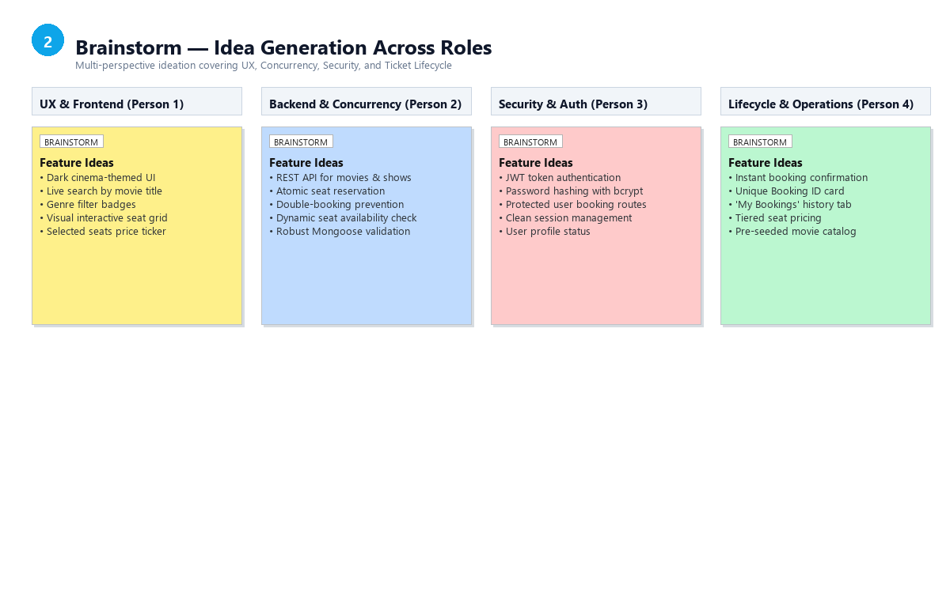
Figure 3.2: Mural Step 2 — Brainstorm Idea Listing Across Functional Roles
- Person 1 (Frontend & UX Focus): Dark cinema-themed aesthetic; real-time movie search input; genre filter pills; high-resolution movie cards; interactive seat selection grid with hover states; real-time selected seats price counter; responsive mobile-first navigation.
- Person 2 (Backend & Transaction Engine Focus): Modular Express REST API; MongoDB data schema with Mongoose models; dynamic showtime query endpoints; atomic seat reservation logic; server-side double-booking prevention; clean error status codes and structured JSON responses.
- Person 3 (Security & Identity Focus): User registration and login; bcrypt password hashing with salt; JSON Web Token (JWT) stateless auth; protected route middleware; secure HTTP headers; token expiration and persistent local session state.
- Person 4 (Booking Lifecycle & Operations Focus): Instant booking confirmation card with unique Reference ID; dedicated 'My Bookings' history dashboard; seat tier pricing (Standard, VIP); printable booking summary; database seeder script with realistic movie and theatre data.
Grouping Ideas into Thematic Functional Clusters
The brainstormed ideas were categorized into four distinct functional clusters:
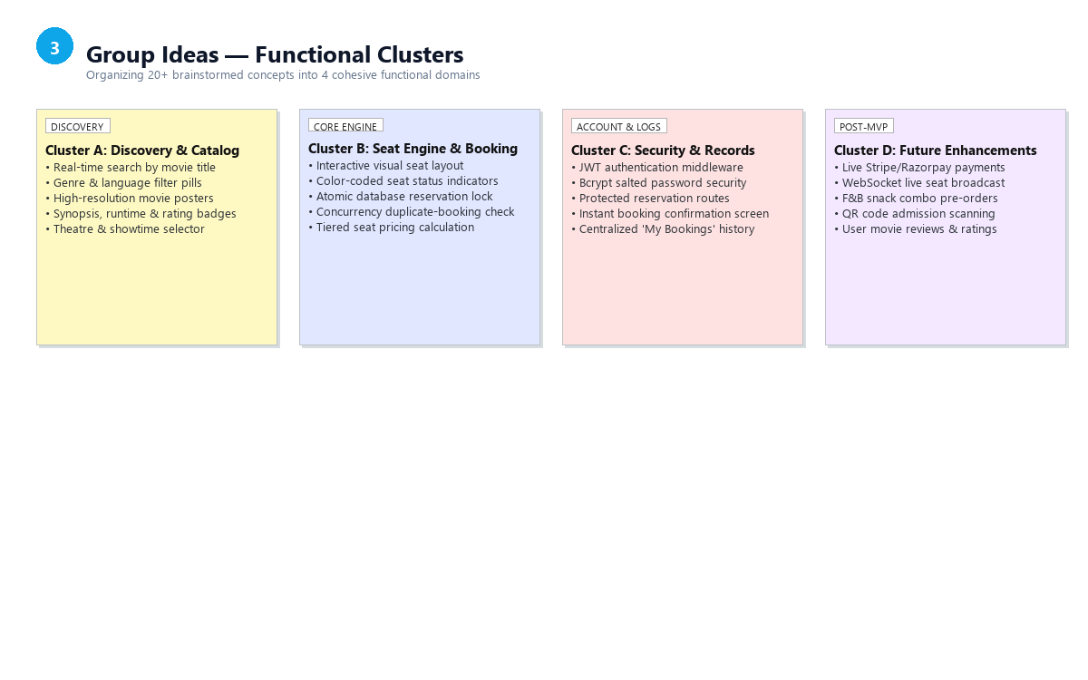
Figure 3.3: Mural Step 3 — Grouping Brainstormed Ideas into Functional Clusters
- Cluster A: Discovery & Catalog Architecture: Covers movie search, genre filtering, poster displays, synopsis, runtime, rating badges, theatre locations, and show schedules.
- Cluster B: Seat Engine & Concurrency Control: Encompasses the visual cinema seat grid, seat status toggling, pricing calculations, backend concurrency checks, and atomic seat locking.
- Cluster C: User Identity, Security & Booking Records: Encompasses JWT authentication, encrypted credentials, user profile management, instant confirmation receipts, and the booking history dashboard.
- Cluster D: Post-MVP & Future Enhancements: Includes external live payment gateways (Stripe/Razorpay), WebSocket broadcasting, food/concession pre-ordering, and QR code gate validation.
Step-3: Idea Prioritization
To establish an achievable, rigorous, and high-impact development roadmap, ideas were evaluated on an Impact vs. Feasibility Matrix. Impact represents user value and core business necessity, while Feasibility represents technical feasibility, development velocity, and suitability for the individual MERN stack scope.
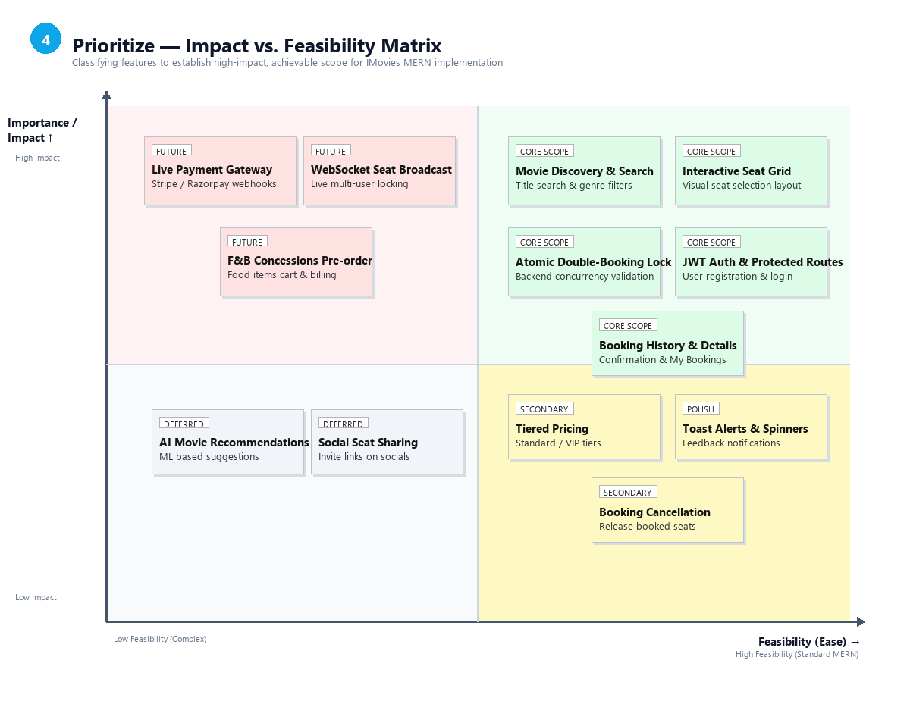
Figure 3.4: Mural Step 4 — Impact vs. Feasibility Prioritization Matrix
Detailed Feature Prioritization & Scope Decision Table
The table below provides a systematic evaluation of all brainstormed features, establishing the final agreed project scope:
Feature Name | Functional Domain | Impact | Feasibility | Quadrant | Agreed Scope
User Auth (JWT + Bcrypt) | Security & Identity | High | High | High Imp / High Feas | Core Scope (Sprint 1)
Movie Catalog & Title Search | Discovery & Catalog | High | High | High Imp / High Feas | Core Scope (Sprint 1)
Genre & Language Filtering | Discovery & Catalog | High | High | High Imp / High Feas | Core Scope (Sprint 1)
Theatre & Showtime Explorer | Discovery & Catalog | High | High | High Imp / High Feas | Core Scope (Sprint 2)
Interactive Seating Grid | Seat Engine | High | High | High Imp / High Feas | Core Scope (Sprint 2)
Atomic Double-Booking Lock | Concurrency Engine | High | High | High Imp / High Feas | Core Scope (Sprint 2)
Booking Confirmation Screen | Booking Records | High | High | High Imp / High Feas | Core Scope (Sprint 2)
My Bookings History Dashboard | Booking Records | High | High | High Imp / High Feas | Core Scope (Sprint 3)
Responsive Dark Cinema UI | UX & Design | High | High | High Imp / High Feas | Core Scope (Sprint 1-3)
Tiered Seat Pricing (Std/VIP) | Seat Engine | Medium | High | Med Imp / High Feas | Secondary (Sprint 3)
Booking Cancellation System | Booking Records | Medium | Medium | Med Imp / Med Feas | Secondary (Sprint 3)
Live Payment Gateway (Stripe) | Financial / Payments | High | Low | High Imp / Low Feas | Future (Post-Submission)
WebSocket Live Seat Sync | Real-Time Comms | High | Low | High Imp / Low Feas | Future (Post-Submission)
4. Scope Summary & Phase Transition
The prioritization process delivers a clear, unambiguous blueprint for IMovies:
- Core Scope Commitment: All 9 Core Scope features are formally selected for complete implementation in Phase 5. They guarantee a fully functional, end-to-end movie ticket booking platform adhering to full-stack MERN standards.
- Payment & Concurrency Boundary: Online payment gateways and WebSocket push mechanisms are consciously separated into future enhancements to ensure the core reservation flow is thoroughly tested, robust, and verifiable.
- Traceability to Phase 2: These prioritized features form the foundational input for the Product Backlog, User Stories, and Sprint Planning in Phase 2.

